11.4 Project: Set Up Users and Groups

1. Domain Controller Server Samba

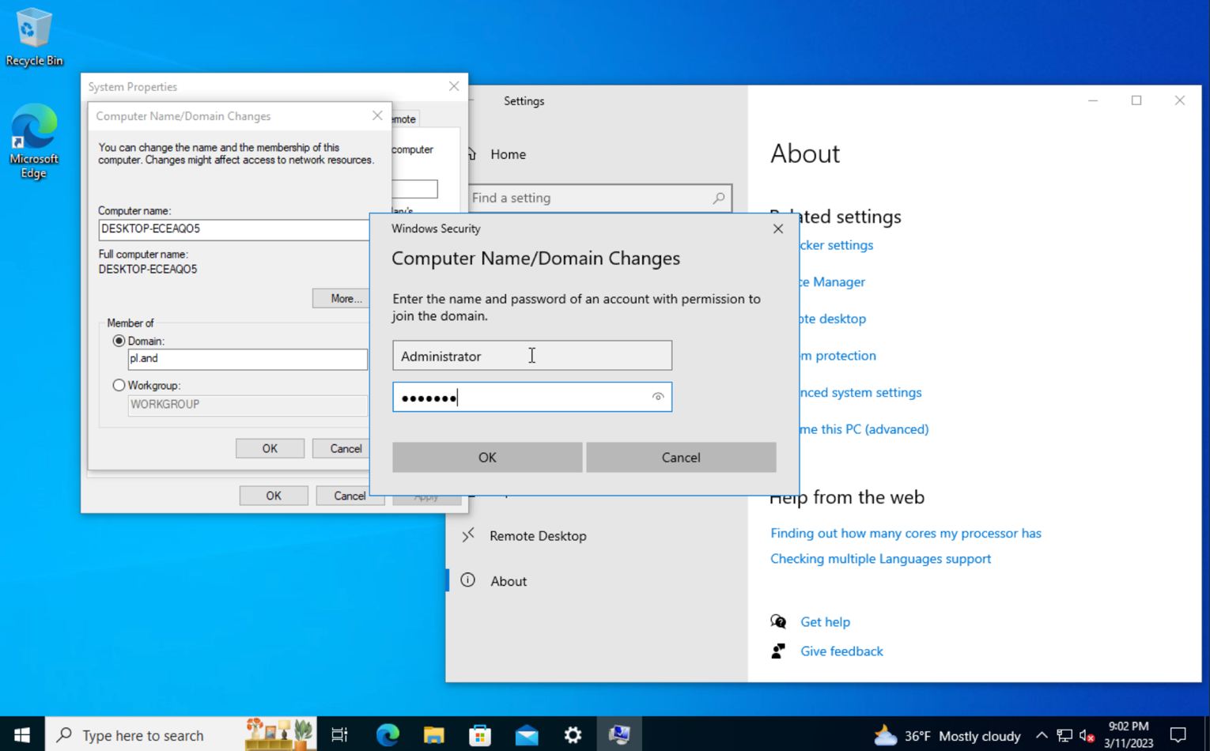

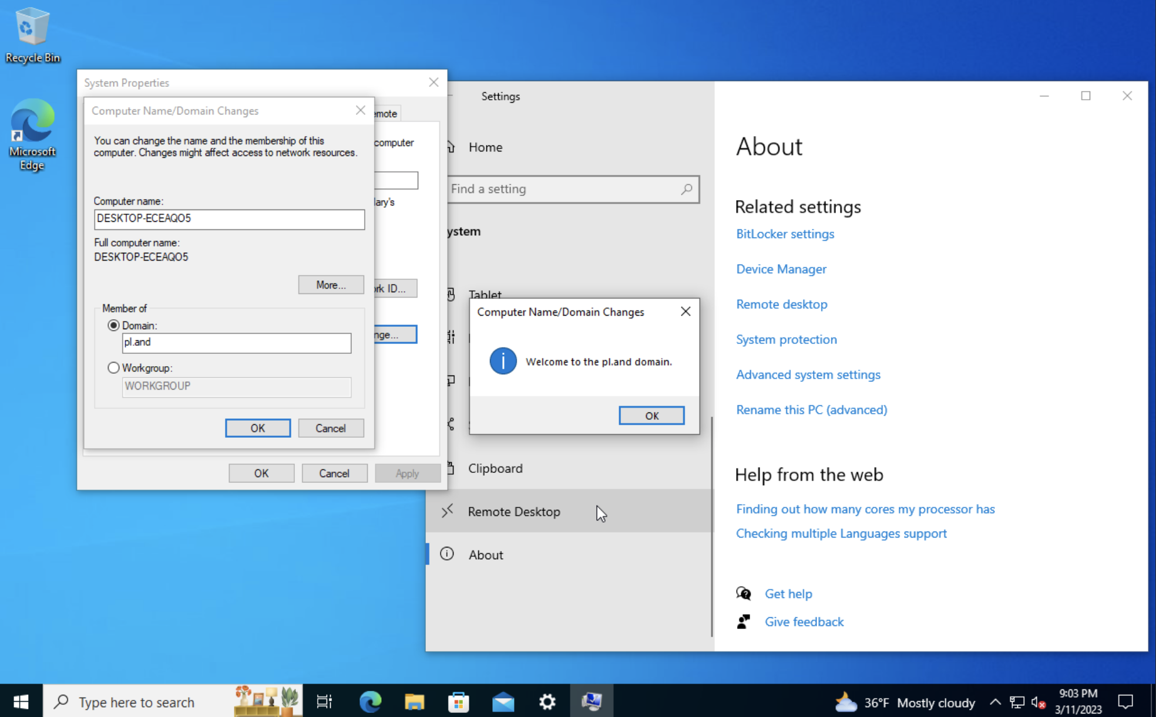

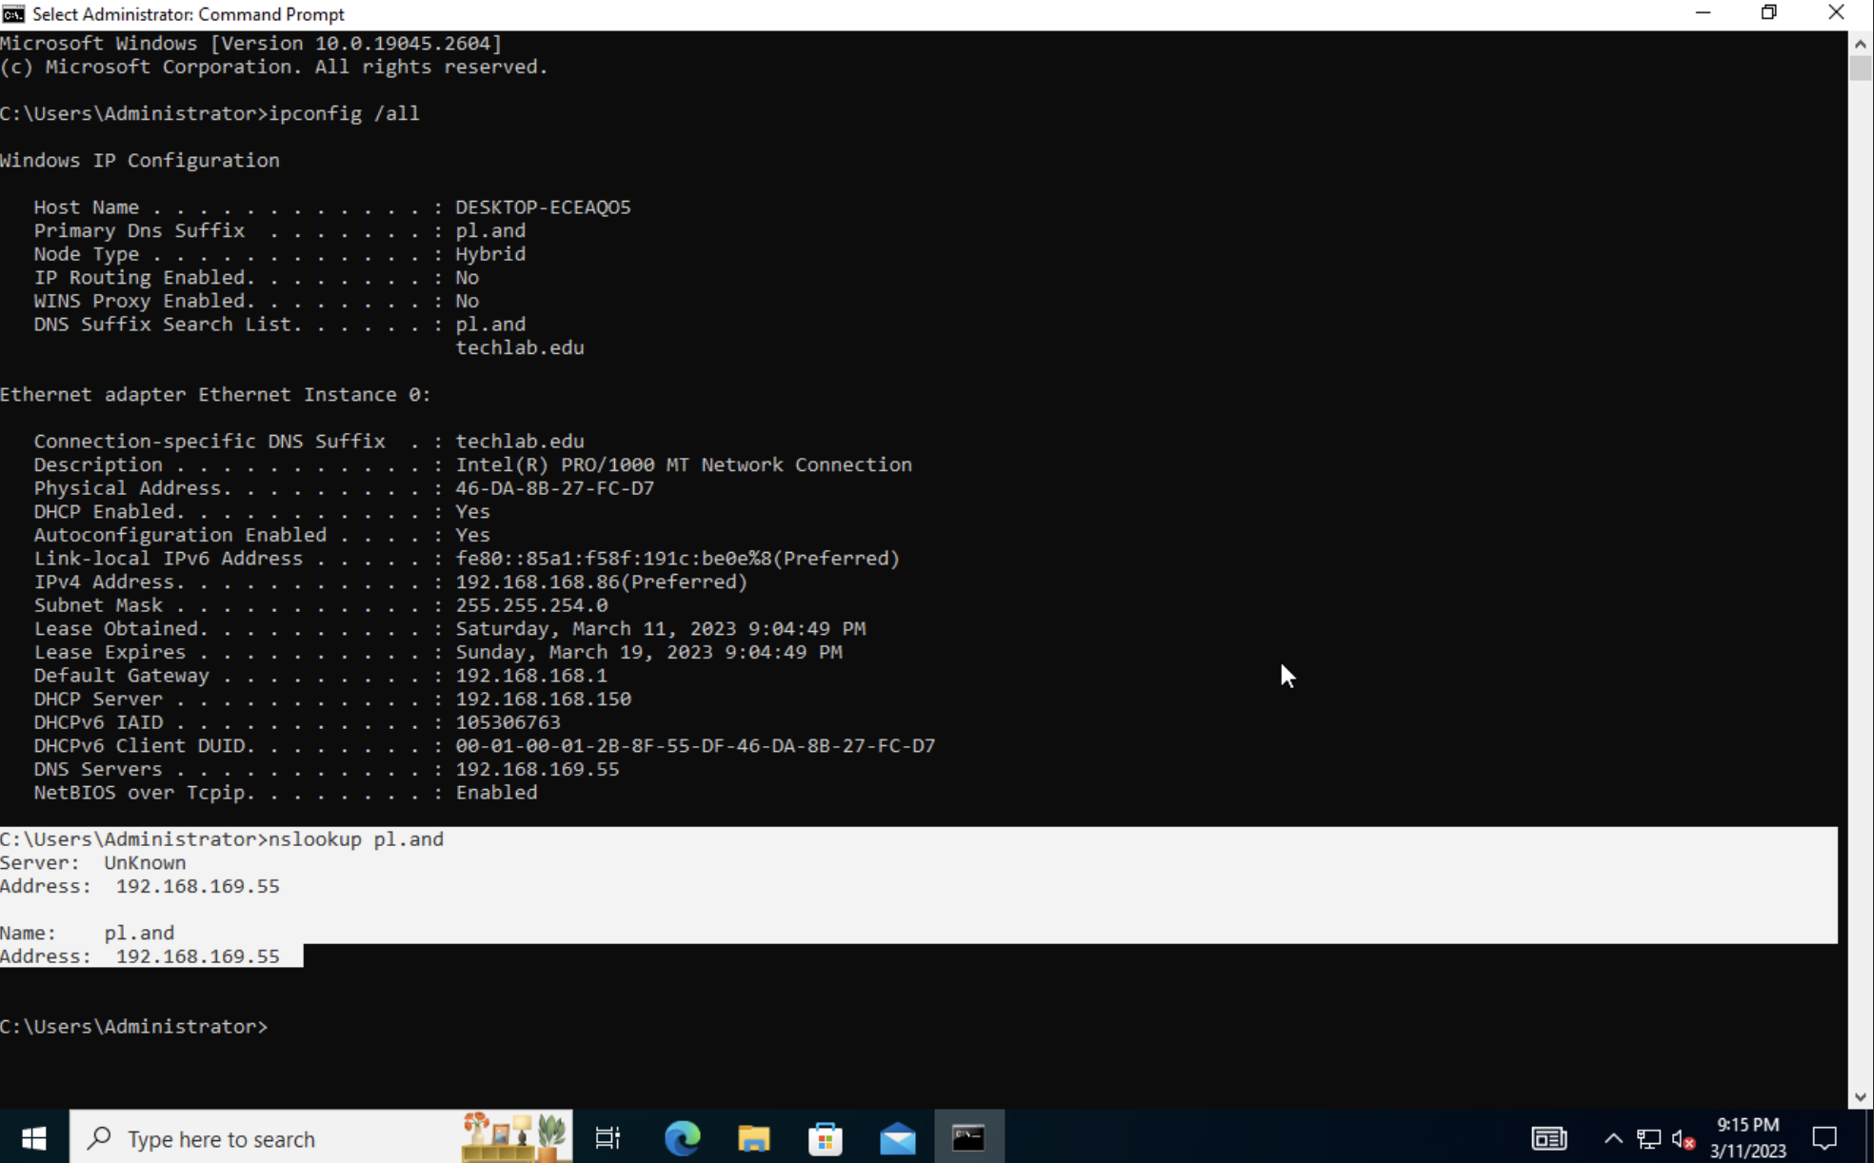

1. Create users for PromisedLand’s organization.

-Add Admin to linux = sudo usermod -a -G harrison , satoko , nicole , gustavo

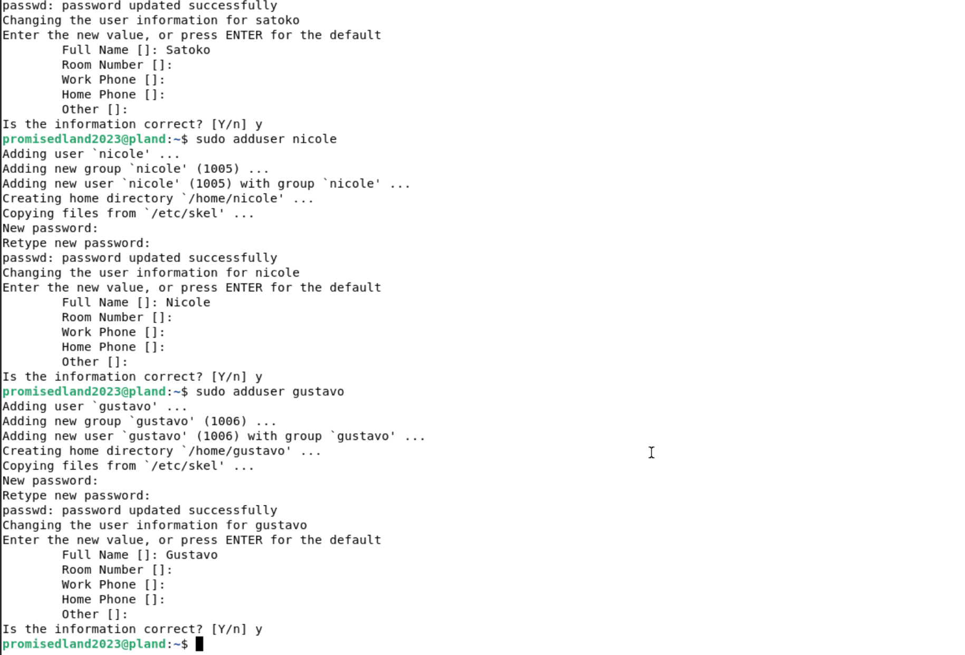

-Add Users samba

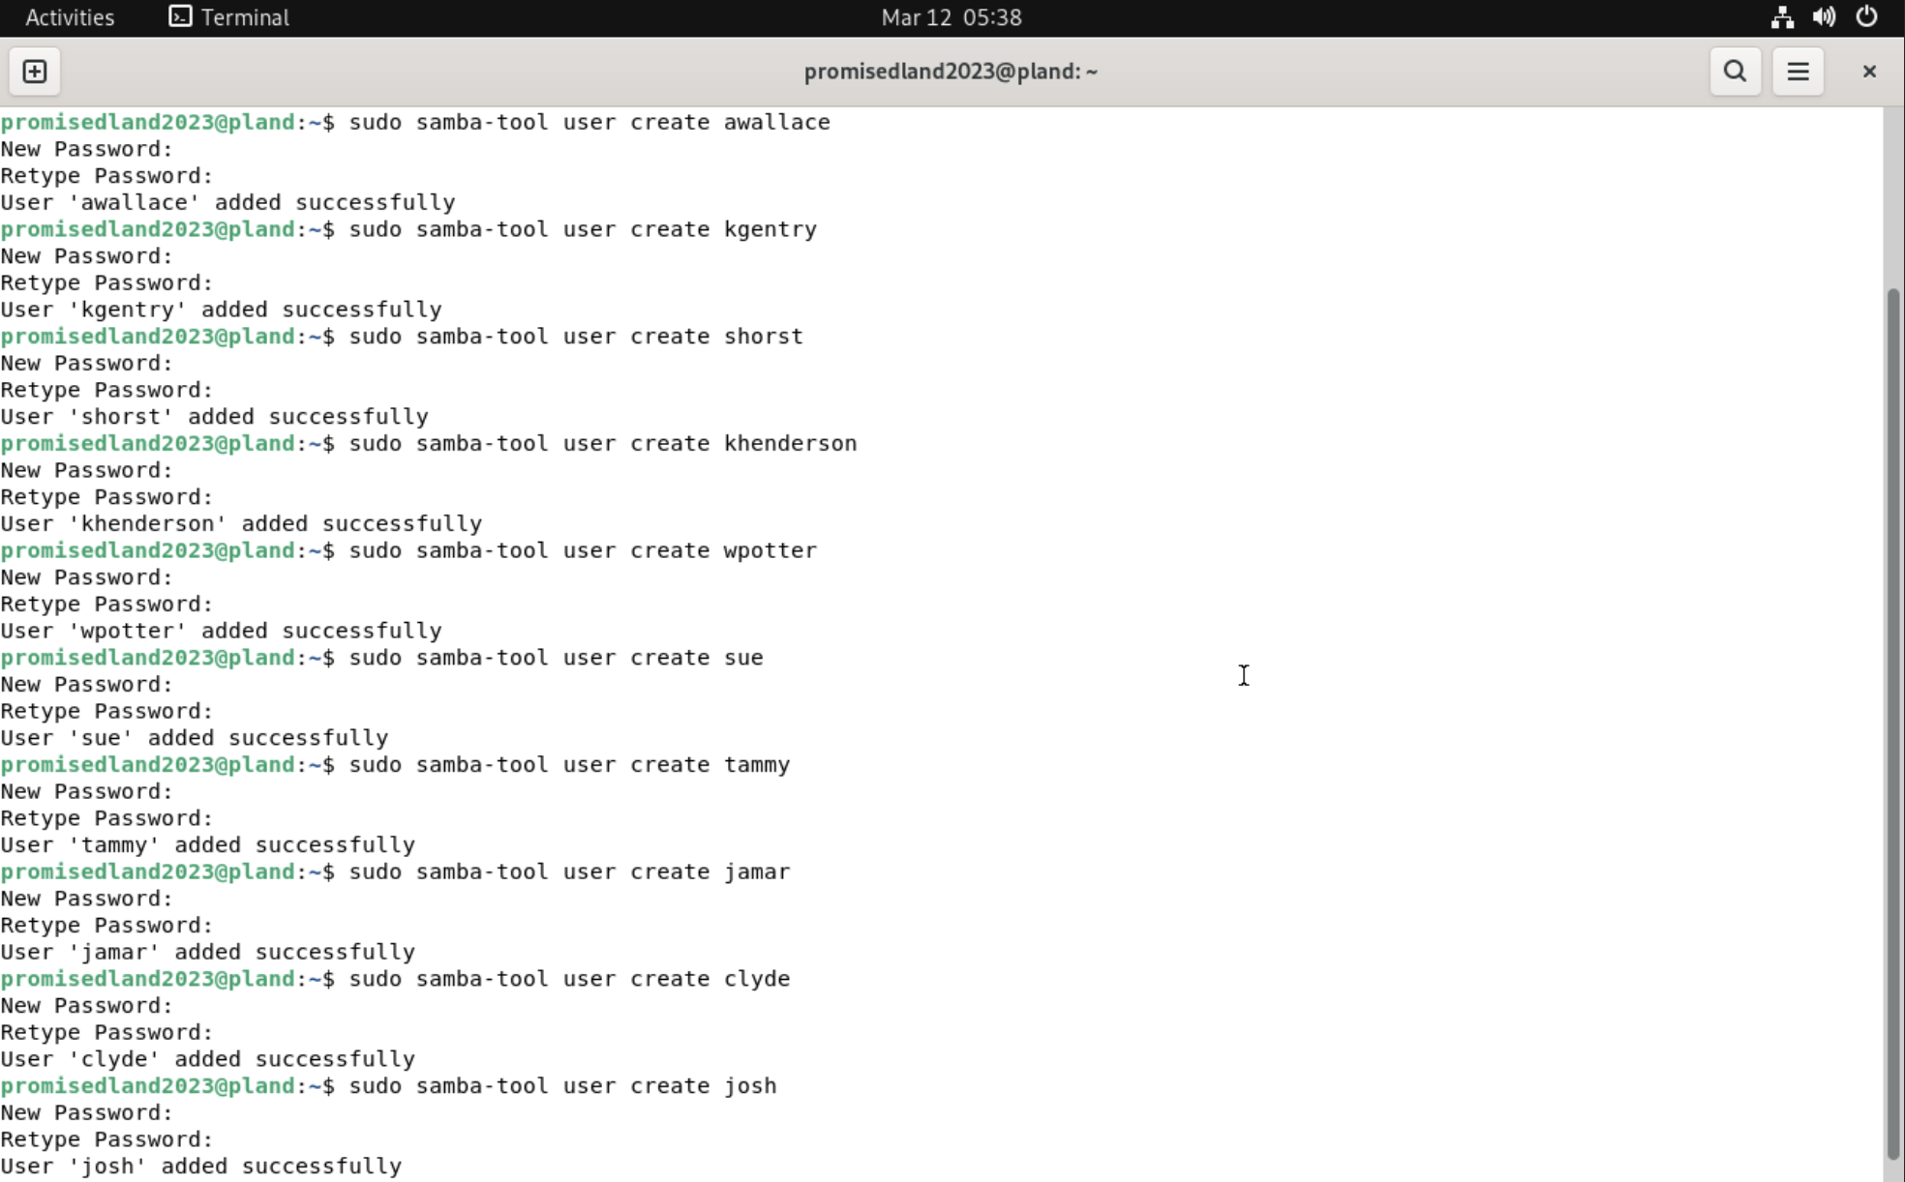

-User list

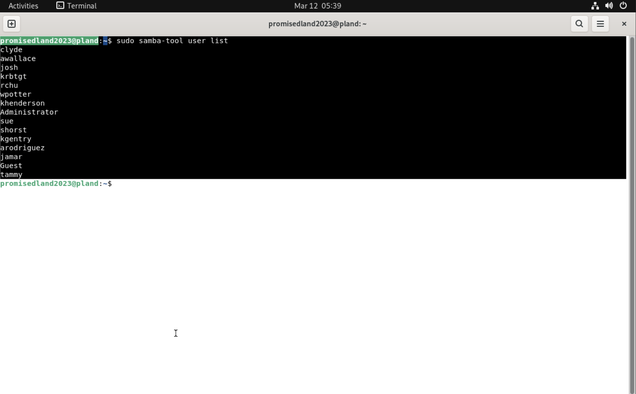

1. Create groups for PromisedLand’s organization.

-Add Groups

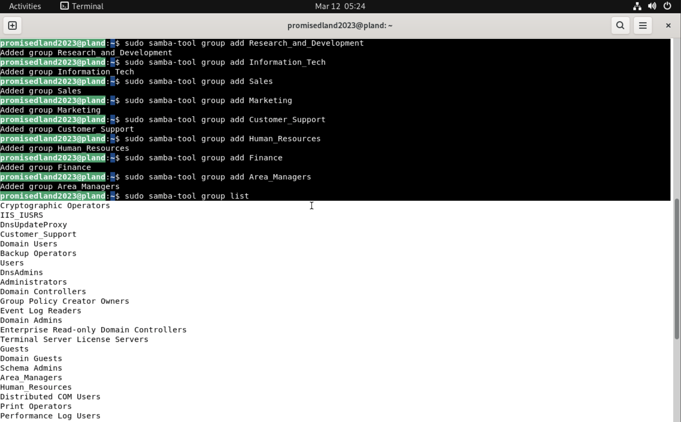

-Group List

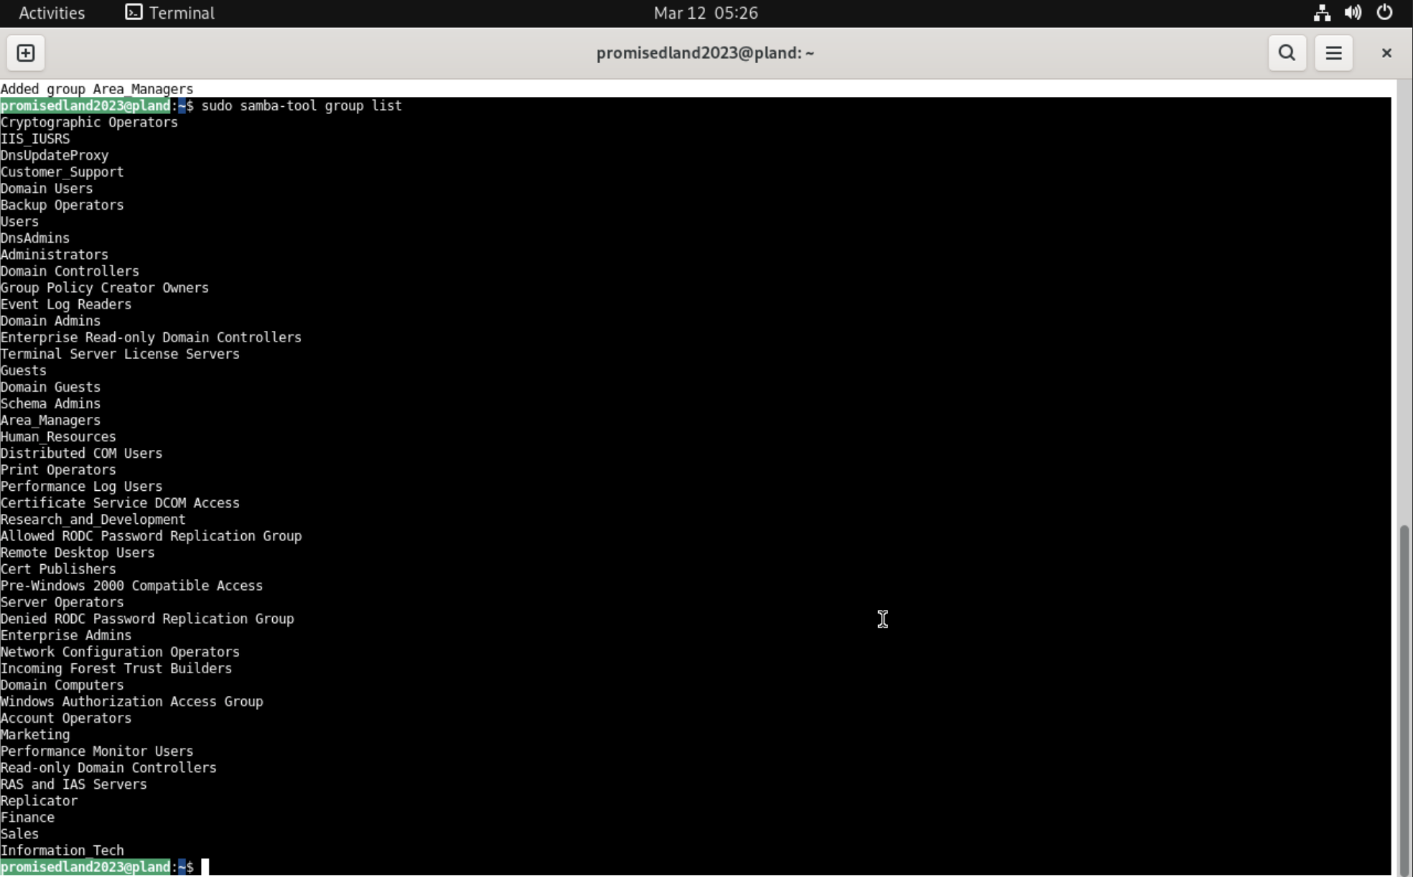

1. Add users to the groups.

-Add Users to group Information_Tech

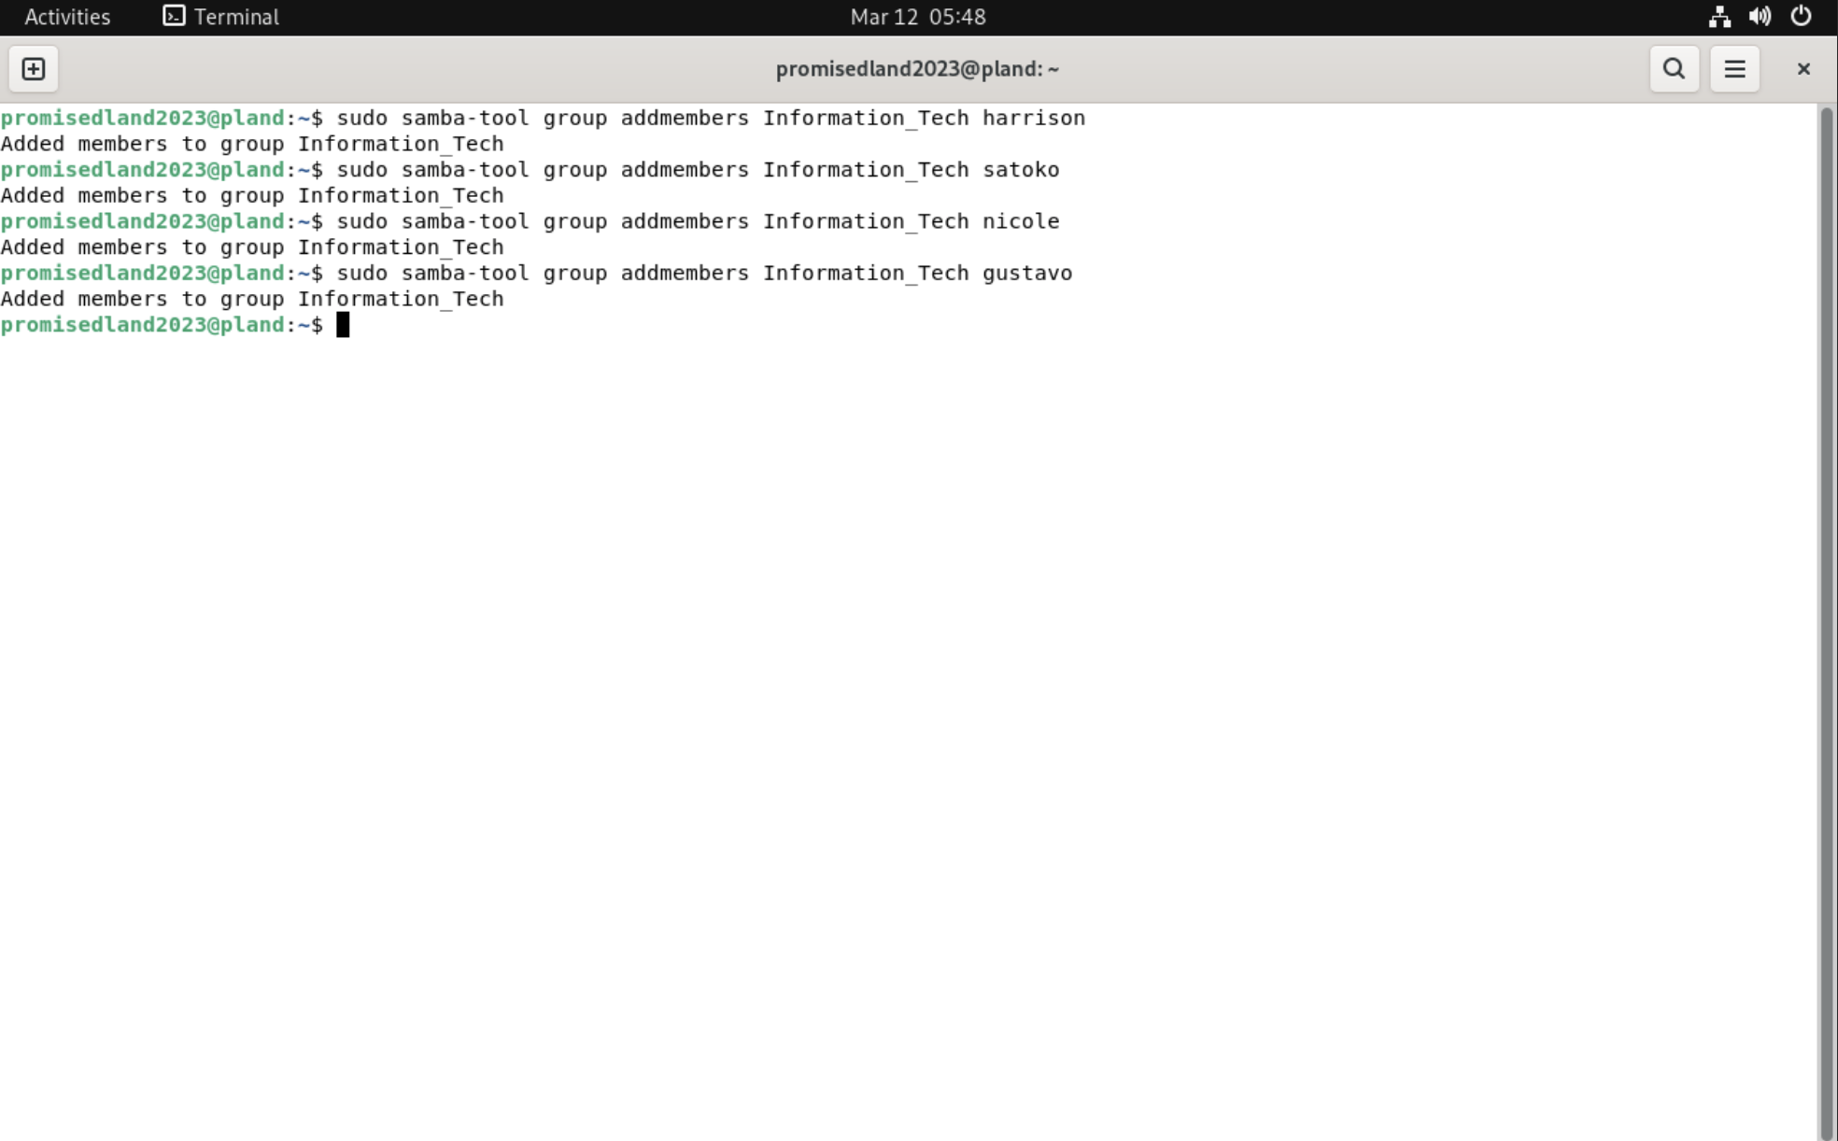

-Information_Tech group listmembers

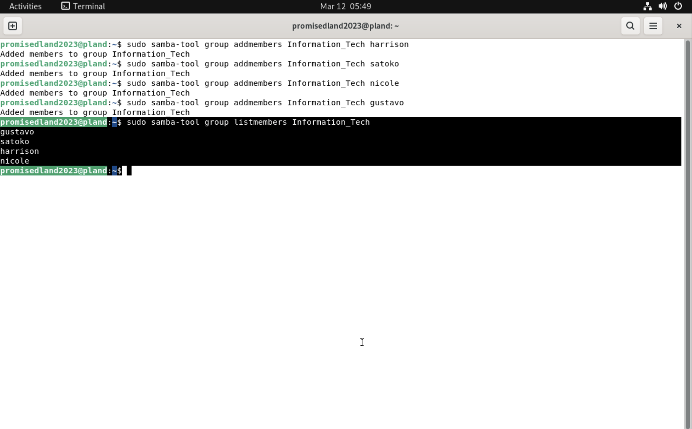

1. Create a project subdirectory in your home directory with your superuser as owner.

-Sudo mkdir dir1, dir2, dir3

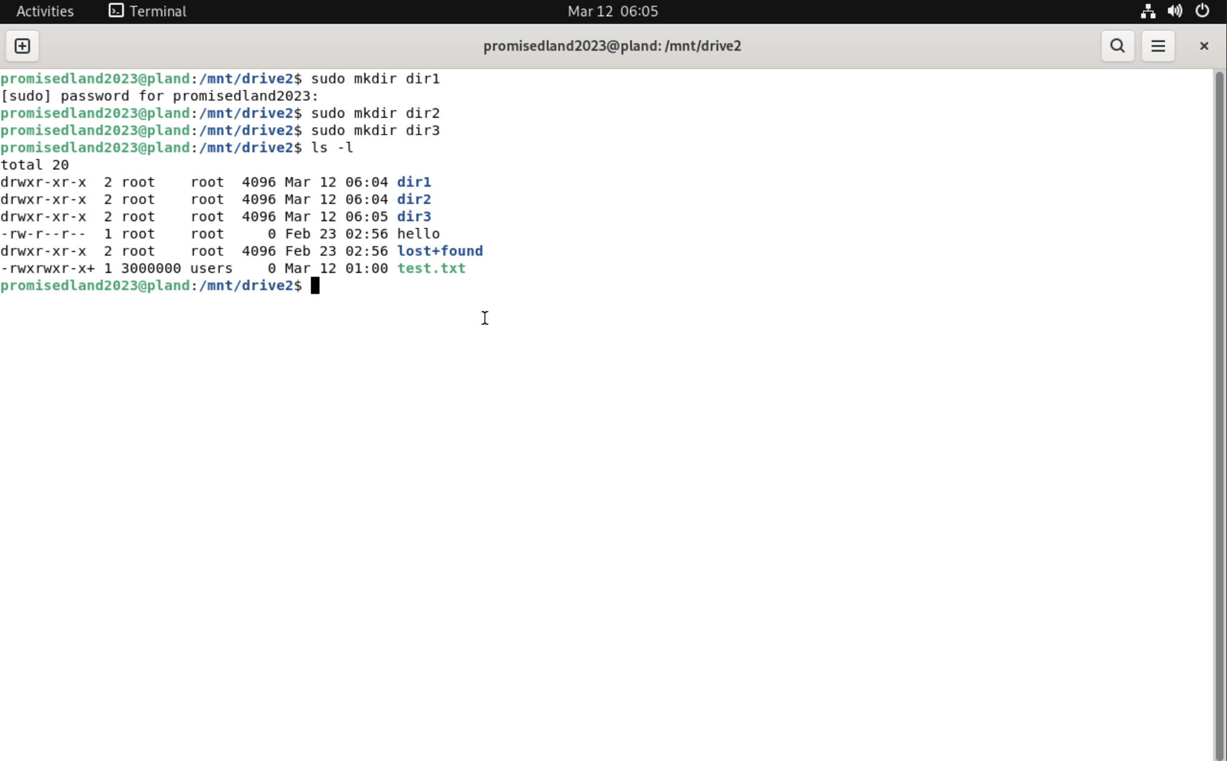

1. Create subdirectories as necessary.

-Sudo mkdir dir1/dir1.1 , dir2/dir2.1 , dir3/dir3.1

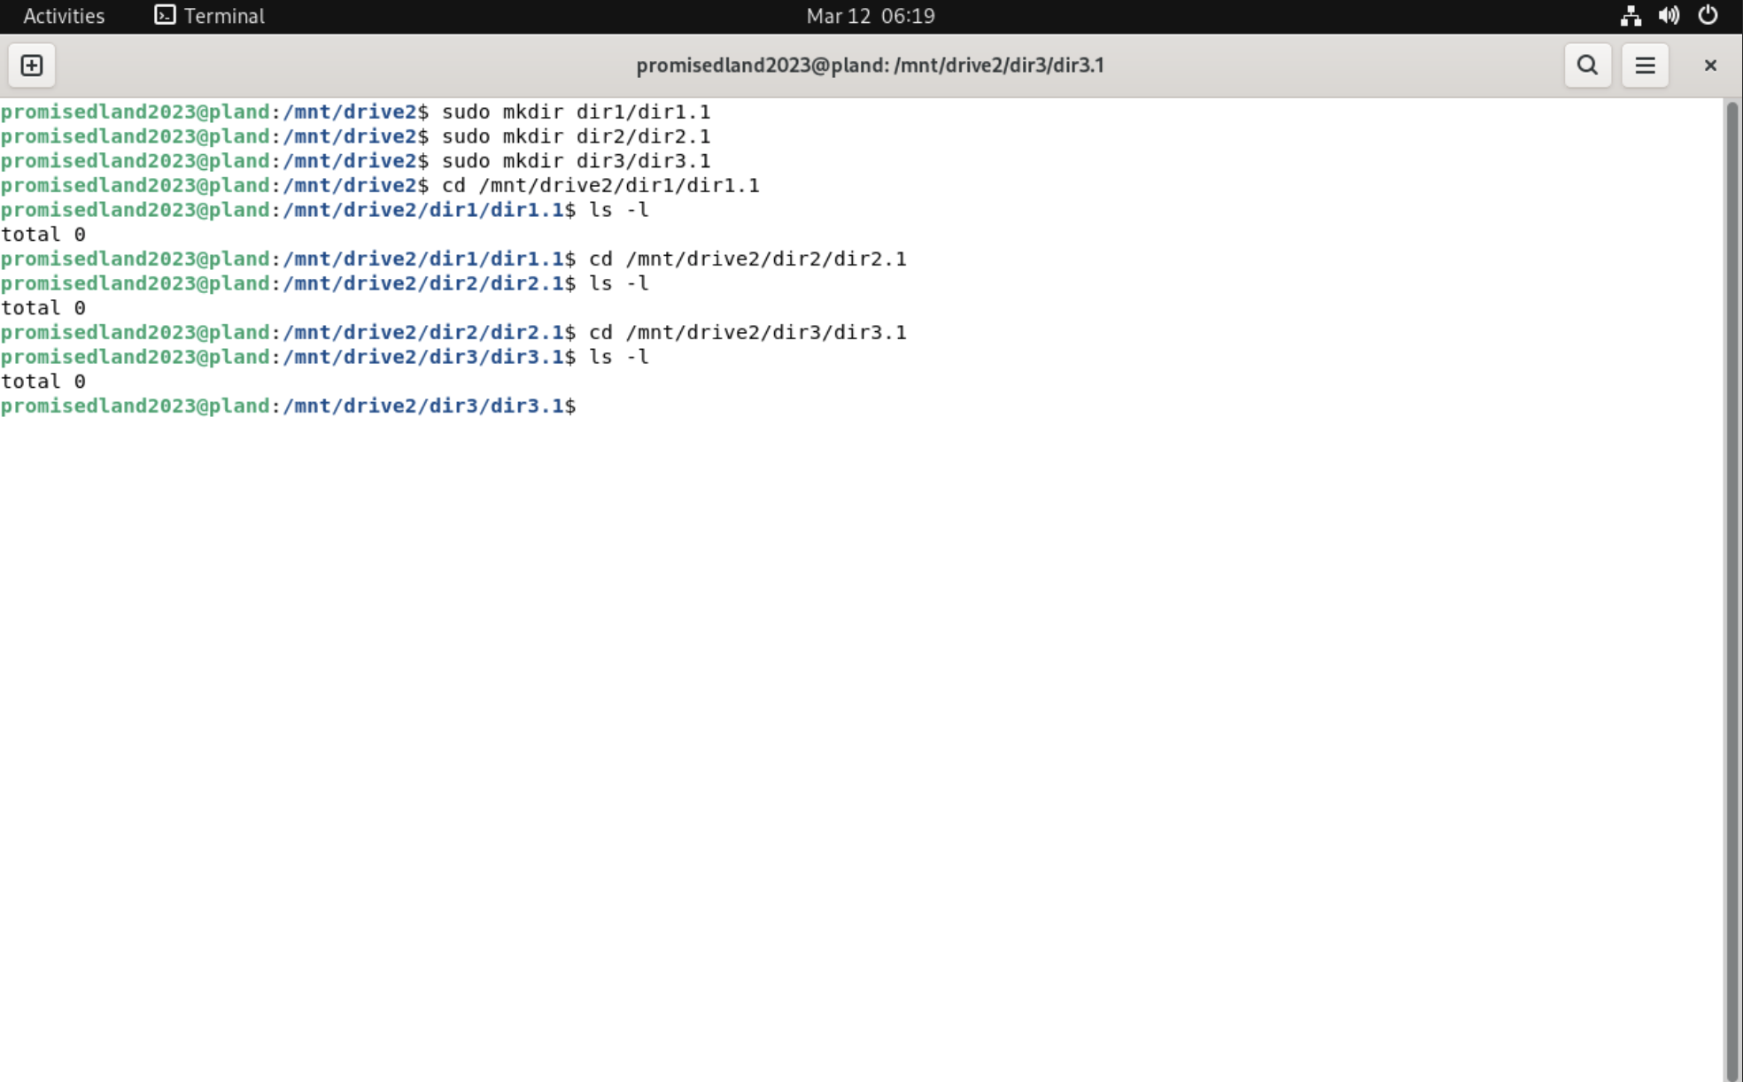

1. Create a text file in each of the subdirectories that is readable and writable by all members of the corresponding group but by no one else.

-sudo touch dir1/text1 , dir2/text2 , dir3/text3

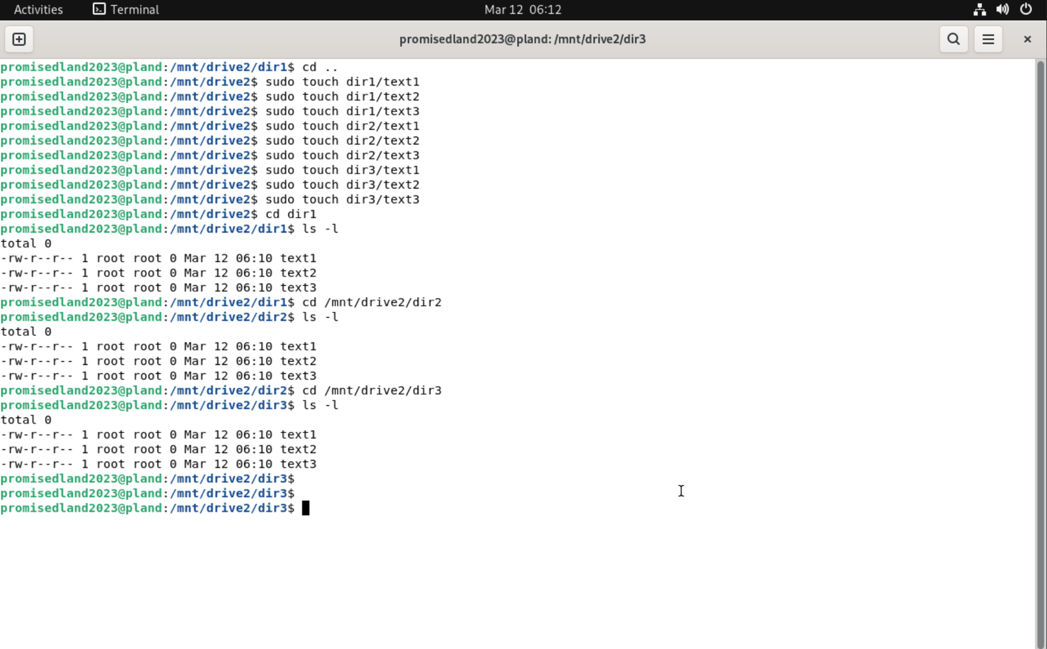

-sudo mkdir gustavodir/gustavodir1.1 ( using user gustavo )

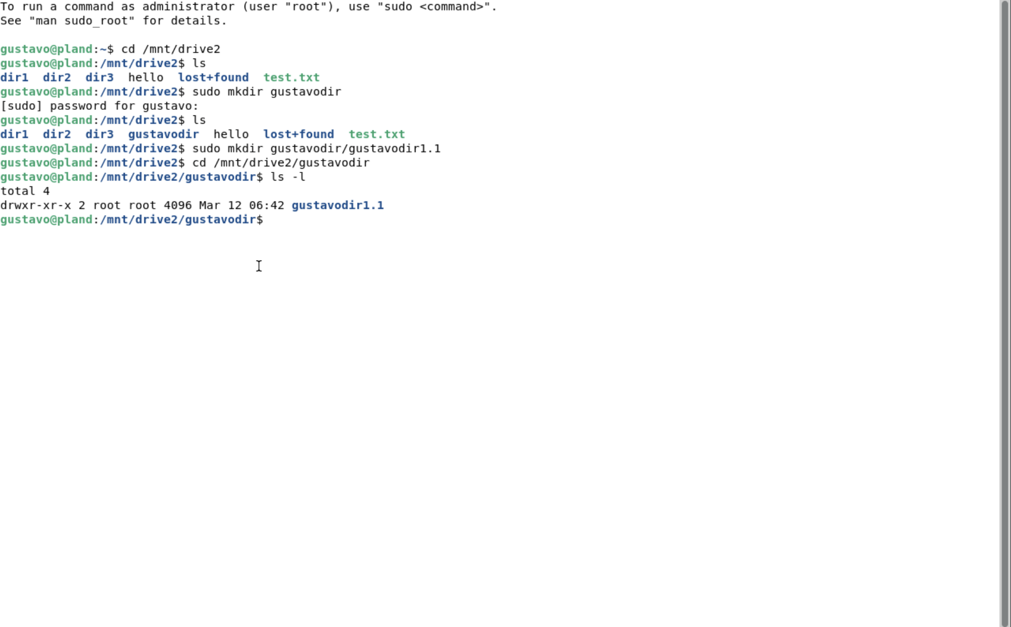

-User: gustavo can add directories, subdirectories and files using samba file in the domain controller

